BT601 – Virology
Lecture # 1
Virus name
The name “virus” has been derived from a Latin word meaning “slimy liquid” or “poison.” Viruses are microscopic parasites that lack the capacity to thrive and reproduce outside of a host body. These can multiply only in living cells of animals, plants, or bacteria. Latin word meaning poison or venom given by Beijerinck (1897).
WHAT ARE VIRUSES?
Viruses are submicroscopic, obligate intracellular parasites. Most are too small to be seen by optical microscopes, and they have no choice but to replicate inside host cells. This simple but useful definition goes a long way toward describing viruses and differentiating them from all other types of organism. However, this short definition is not completely adequate.
Viruses are unique in nature. They are the smallest of all self-replicating organisms, historically characterized by their ability to pass through filters that retain even the smallest bacteria. In their most basic form, viruses consist solely of a small segment of nucleic acid encased in a simple protein shell. Viruses have no metabolism of their own but rather are obliged to invade cells and parasitize subcellular machinery, subverting it to their own purposes.
Virus Size
- Submicroscopic
  - Smaller than bacteria
  - Smaller than the smallest cell
Lecture # 2
Discovery of Virus
Human knowledge of virus diseases goes back a long way, although it is only much more recently that we have become aware of viruses as distinct from other causes of disease. The first written record of a virus infection is a hieroglyph from Memphis, the capital of ancient Egypt, drawn in approximately 3700 BC, which depicts a temple priest showing typical clinical signs of paralytic poliomyelitis.
Edward Jenner in May, 1796, used cowpox-infected to successfully vaccinate 8-year-old James Phipps.
Although initially controversial, vaccination against smallpox was almost universally adopted worldwide during the nineteenth century.
In 1892, Dimitri Iwanowski, a Russian botanist, showed that extracts from diseased tobacco plants could transmit disease to other plants after being passed through ceramic filters fine enough to retain the smallest known bacteria. Unfortunately, he did not realize the full significance of these results.
A few years later (1898), Martinus Beijerinick confirmed and extended Iwanowski’s results on tobacco mosaic virus (TMV) and was the first to develop the modern idea of the virus, which he referred to as contagium vivum fluidum (“soluble living germ”).
In 1898 Beijernick Studied filtered diseased plant juices and found the caused disease in healthy plants
Wendell Stanley (1935) discovered that: Viruses are composed of protein and nucleic acid Studied Diseased tobacco plants TMV. He discovered isolates of virus and won Nobel award.
Freidrich Loeffler and Paul Frosch (1898) showed that a similar agent was responsible for foot-and-mouth disease in cattle, but, despite the realization that these new-found agents caused disease in animals as well as plants, people would not accept the idea that they might have anything to do with human diseases.
This resistance was finally dispelled in 1909 by Karl Landsteiner and Erwin Popper, who showed that poliomyelitis was caused by a “filterable agent”—the first human disease to be recognized as being caused by a virus.
Frederick Twort (1915) and Felix d’Herelle (1917) were the first to recognize viruses that infect bacteria, which d’Herelle called bacteriophages (“eaters of bacteria”). Investigation of bacteriophages established the foundations for the field of molecular biology, as well as fundamental
Insights into how viruses interact with their host cells.
Lecture # 3
HISTORY OF VIROLOGY
The first written record of a virus infection is a hieroglyph from Memphis, the capital of ancient Egypt, drawn in approximately 3700 BC, which depicts a temple priest showing typical clinical signs of paralytic poliomyelitis.
Pharaoh Ramses V, who died in 1196 BC and whose well-preserved mummified body is now in a Cairo museum, is believed to have died from smallpox—the comparison between the pustules on the face of this mummy and those of more recent patients is startling.
Smallpox was endemic in China by 1000 BC. In response, the practice of variolation was developed. Recognizing that survivors of smallpox outbreaks were protected from subsequent infection, people inhaled the dried crusts from smallpox lesions like snuff or, in later modifications, inoculated the pus from a lesion into a scratch on the forearm. Variolation was practiced for centuries and was shown to be an effective method of disease prevention, although risky because the outcome of the inoculation was never certain.
Edward Jenner was nearly killed by variolation at the age of seven. Not surprisingly, this experience spurred him on to find a safer alternative treatment. On May 14, 1796, he used cowpox-infected material obtained from the hand of Sarah Nemes, a milkmaid from his home village of Berkeley in Gloucestershire, England, to successfully vaccinate 8-year-old James Phipps. Although initially controversial, vaccination against smallpox was almost universally adopted worldwide during the nineteenth century.
In 1892, Dimitri Iwanowski, a Russian botanist, showed that extracts from diseased tobacco plants could transmit disease to other plants after being passed through ceramic filters fine enough to retain the smallest known bacteria. Unfortunately, he did not realize the full significance of these results. A few years later (1898), Martinus Beijerinick confirmed and extended Iwanowski’s results on tobacco mosaic virus (TMV) and was the first to develop the modern idea of the virus, which he referred to as contagium vivum fluidum (“soluble living germ”).
In 1898 Beijernick Studied filtered diseased plant juices and found the caused disease in healthy plants
Wendell Stanley (1935) discovered that: Viruses are composed of protein and nucleic acid Studied Diseased tobacco plants TMV
In the 1930s and subsequent decades, pioneering virologists such as Salvador Luria, Max Delbruck, and others used these viruses as model systems to investigate many aspects of virology, including virus structure, genetics , and replication.
These relatively simple agents have since proved to be very important to our understanding of all types of viruses, including those of humans which can be much more difficult to propagate and study. The further history of virology is the story of the development of experimental tools and systems with which viruses could be examined and which opened up whole new areas of biology, including not only the biology of the viruses themselves but inevitably also the biology of the host cells on which they are dependent.
Lecture # 4
UNIQUE PROPERTIES
Living as well as non-living characteristics
Unable to cultivate in laboratory easily
Simplest structure
Complex interaction with host
Replication within host
To study an important class of pathogens
Many types of pathogens cause disease in humans. The most familiar are viruses and bacteria. Viruses cause diseases ranging from AIDS and smallpox to the common cold. They are essentially fragments of nucleic acid (DNA or RNA) instructions, wrapped in a protective shell of proteins and (in some cases) membrane. They use the basic transcription and translation machinery of their host cells for their replication.
Of all the bacteria we encounter in our lives, only a small minority are dedicated pathogens. Much larger and more complex than viruses, bacteria are usually free-living cells, which perform most of their basic metabolic functions themselves, relying on the host primarily for nutrition.
Some other infectious agents are eukaryotic organisms. These range from single-celled fungi and protozoa, through large complex metazoan such as parasitic worms.
Some rare neurodegenerative diseases, including mad cow disease, are caused by an unusual type of infectious particle called a prion, which is made only of protein. Although the prion contains no genome, it can nevertheless replicate and kill the host.
Even within each class of pathogen, there is striking diversity. Viruses vary tremendously in their size, shape, and content, and the same is true for the other pathogens. The ability to cause disease (pathogenesis) is a lifestyle choice, not a legacy shared only among close relatives
Virus life cycle
Bacteria, fungi, and eukaryotic parasites are cells themselves. Even when they are obligate parasites, they use their own machinery for DNA replication, transcription, and translation, and they provide their own sources of metabolic energy. Viruses, by contrast, are the ultimate hitchhikers, carrying little more than information in the form of nucleic acid. The information is largely replicated, packaged, and preserved by the host cells. Viruses have a small genome, made up of a single nucleic acid type—either DNA or RNA. The genome is packaged in a protein coat.
Viruses replicate in various ways. In general, replication involves (1) disassembly of the infectious virus particle, (2) replication of the viral genome, (3) synthesis of the viral proteins by the host cell translation machinery, and (4) reassembly of these components into progeny virus particles.
To study viral cultivation in lab
Tissue culture
Embryonated egg
Live animal
Lecture # 5
Viruses are infectious agents with both living and non-living characteristics. They can infect animals, plants, and even other microorganisms.
Living Characteristics of Viruses:
They reproduce at a fantastic rate, but only in living host cells.
They can mutate.
Nonliving Characteristics of Viruses
They are a cellular, that is, they contain no cytoplasm or cellular organelles.
They carry out no metabolism on their own and must replicate using the host cell’s metabolic machinery. In other words, viruses don’t grow and divide. Instead, new viral components are synthesized and assembled within the infected host cell.
The vast majority of viruses possess either DNA or RNA but not both.
CONCLUSION
Viruses are:
“exceptionally complex aggregation of non-living chemicals”
OR
“ exceptionally simple living organisms”
Recently, viruses have been declared as living entities based on the large number of protein folds encoded by viral genomes that are shared with the genomes of cells. This indicates that viruses likely arose from multiple ancient cells.
Lecture # 6
The evolutionary history of viruses represents a fascinating topic for virologists and cell biologists. Because of the great diversity among viruses, biologists have struggled with how to classify these entities and how to relate them to the conventional tree of life. They may represent genetic elements that gained the ability to move between cells. They may represent previously free-living organisms that became parasites. They may be the precursors of life as we know it.
Where Did Viruses Come From?
There is much debate among virologists about this question. Three main hypotheses have been articulated:
- The virus-first hypothesis states that viruses predate or coevolved with their current cellular hosts. The progressive, or escape, hypothesis states that viruses arose from genetic elements that gained the ability to move between cells
- The regressive, or reduction, hypothesis asserts that viruses are remnants of cellular organisms
- The virus-first hypothesis
They may have originated and evolved with the other life forms. One postulate showed that viruses existed in a precellular world as self-replicating units. Over time these units, they argue, became more organized and more complex.
B.The Progressive Hypothesis
According to this hypothesis, viruses originated through a progressive process. Mobile genetic elements, pieces of genetic material capable of moving within a genome, gained the ability to exit one cell and enter another. To conceptualize this transformation, let’s examine the replication of retroviruses, the family of viruses to which HIV belongs.
Retroviruses have a single-stranded RNA genome. When the virus enters a host cell, a viral enzyme, reverse transcriptase, converts that single-stranded RNA into double-stranded DNA. This viral DNA then migrates to the nucleus of the host cell. Another viral enzyme, integrase, inserts the newly formed viral DNA into the host cell’s genome. Viral genes can then be transcribed and translated. The host cell’s RNA polymerase can produce new copies of the virus’s single-stranded RNA genome. Progeny viruses assemble and exit the cell to begin the process again.
C. The Regressive Hypothesis
In contrast to the progressive process just described, viruses may have originated via a regressive, or reductive, process. Microbiologists generally agree that certain bacteria that are obligate intracellular parasites, like Chlamydia and Rickettsia species, evolved from free-living ancestors. Indeed, genomic studies indicate that the mitochondria of eukaryotic cells and Rickettsia prowazekii may share a common, free-living ancestor. It follows, then, that existing viruses may have evolved from more complex, possibly free-living organisms that lost genetic information over time, as they adopted a parasitic approach to replication.
No Single Hypothesis May Be Correct
Where viruses came from is not a simple question to answer. One can argue quite convincingly that certain viruses, such as the retroviruses, arose through a progressive process. Perhaps today’s viruses arose multiple times, via multiple mechanisms. Perhaps all viruses arose via a mechanism yet to be uncovered. Today’s basic research in fields like microbiology, genomics, and structural biology may provide us with answers to this basic question.
Lecture # 7

Lecture # 8
VIRUS
A virus is a sub-microscopic particle that can infect living cells. Viruses are much smaller than prokaryotes, ranging in size from about 20–300 nanometers (nm), though some can be larger. Prokaryotes are typically 0.5–5.0 micrometers (µm) in length. For example, if a virus was about the size of three soccer balls lying side-by-side, then a prokaryote would be about the size of soccer field.
Structure
An individual virus is called a virion. It is a tiny particle much smaller than a prokaryotic cell. Because viruses do not consist of cells, they also lack cell membranes, cytoplasm, ribosomes, and other cell organelles. Without these structures, they are unable to make proteins or even reproduce on their own. Instead, they must depend on a host cell to synthesize their proteins and to make copies of themselves. Although viruses are not classified as living things, they share two important traits with living things. They have genetic material, and they can evolve.
Simple Viruses
A protective protein coat
A nucleic acid genome
Deoxyribonucleic Acid (DNA)
Or
Ribonucliec Acid (RNA)
WHY VIRUSES NEED HOST?
No enzymes of their own
No metabolism
Require host machinery
COMPLEX VIRUSES
Simple viruses only contain protein coat and nucleic acid genome. Complex viruses also contains some additional contents e.g.
Lipid
Polysaccharides
Trace elements
Lecture # 9
Structure of enveloped and non-enveloped viruses. Non-enveloped viruses are composed of capsid protein and nucleic acid (DNA or RNA), viz. Nucleocapsid. Whereas enveloped viruses are composed of an envelope and nucleocapsid. Some viruses may have spikes to help attach to the host cell. Most viruses infect only specific host cells

Envelope

Viruses- Structure, Replication and Diagnosis

MORPHOLOGY
Viruses come in a variety of shapes.
Helical Viruses: Protein subunits interact with each other and with the nucleic acid to form a coiled, ribbon like structure: e.g. tobacco mosaic virus, influenza virus, rabies virus. Ebola virus. Structures with helical symmetry.
Polyhedral shapes: The capsid shell is made of repeating subunits of viral protein (may be one kind of subunit or several, according to the virus). – All faces of the icosahedron are identical. Like the influenza virus
Complex shapes: Most viruses have either icosahedral or helical capsids, but some viruses do not fit into either category. Poxviruses and large bacteriophages are two important examples.
Lecture # 10
Viruses are usually much smaller than bacteria with the vast majority being submicroscopic. While most viruses range in size from 5 to 300 nanometers (nm) (1 nanometre = 10-9 meters). In recent years a number of giant viruses, including Mimiviruses and Pandoraviruses with a diameter of 0.4 micrometers (µm), have been identified. By contrast, the smallest bacteria are about 400 nanometers in size.
Viruses are much smaller than the cells they infect. Indeed, it was their remarkable smallness that led to their discovery in the first place. Researchers were puzzled by remnant infectious elements that could pass through filters small enough to remove pathogenic bacterial cells. This led to the hypothesis of a new form of biological entity. These entities were subsequently identified as viruses.
Most common human viruses with their relative size
Lecture # 11
Chemical Constitution of Virus
Viruses are mainly composed of proteins and nucleic acids.
Proteins: The constituent building blocks of proteins are the amino acids, and most of the common amino acids are found in viruses. The analyses of viral proteins have shown that viral proteins are not histones, but are rather ordinary in composition, being even, in some cases, quite acidic in character.
Nucleic acids: Ribonucleic acid (RNA) or deoxyribonucleic acid (DNA) is found in viruses. Only RNA has been found in the viruses affecting higher plants, whereas RNA or DNA, have been reported to be present in highly purified preparations of animal viruses. Nucleic acids, largely because of their primary phosphate groups, are customarily regarded as very reactive compounds. However, in viruses, they are chemically inert. A few enzymes may also be found in viruses. Some other miscellaneous constituents of viruses include nucleoproteins, lipids, polysaccharide, copper, biotin, and flavin.
The protein subunits in a virus capsid are redundant, that is, there are many copies in each particle. Damage to one or more capsid subunits may make that particular subunit nonfunctional, but rarely does limited damage destroy the infectivity of the entire particle. This helps make the capsid an effective barrier. This combination of strength, flexibility, and small size means that it is physically difficult (although not impossible) to break open virus particles by physical pressure.
SPECIFICITY
The outer surface of the virus is also responsible for recognition of and inter-action with the host cell. Initially, this takes the form of binding of a specific virus-attachment protein to a cellular receptor molecule. However, the capsid also has a role to play in initiating infection by delivering the genome in a form in which it can interact with the host cell. In some cases, this is a simple process that consists only of dumping the genome into the cytoplasm of the cell. Most viruses infect specific host cells i.e. are host specific.
Host specificity is due to:
Specific attachment sites on the host cells called receptors
Receptor sites for bacteriophage are found in bacterial cell walls or fimbrae or flagella
Animal cell membranes contain receptors for animal viruses
Availability of cellular factors required for viral multiplication in the host cells
INFECTIVITY
For infectivity in host cells:
Viral nucleic acid
Viral structural sub components (spikes or glycoproteins)
Enzymes induced in host cells (polymerase enzymes)
Lecture # 12
Viruses are a diverse group of pathogens that have taken widely different life-cycle and genome storage approaches. Perhaps unsurprisingly, assembled viral particles that make up the infectious unit are highly diverse in shape and size. Virion sizes can range from 400 nm in diameter for DNA viruses such as mimivirus and poxviruses to small virions of ~25nm for polio virus. Morphology can also vary widely, from filamentous ebolavirus and marburgvirus virions to pleomorphic viruses such as measles to highly regular “brick” shaped poxvirions.
Characterization of virus particles is typically performed using higher resolution approaches such as electron microscopy or atomic force microscopy. These approaches require purification of virions away from their normal millieu, requiring significant levels of expertise, and can only enumerate small numbers of particles per field of view.
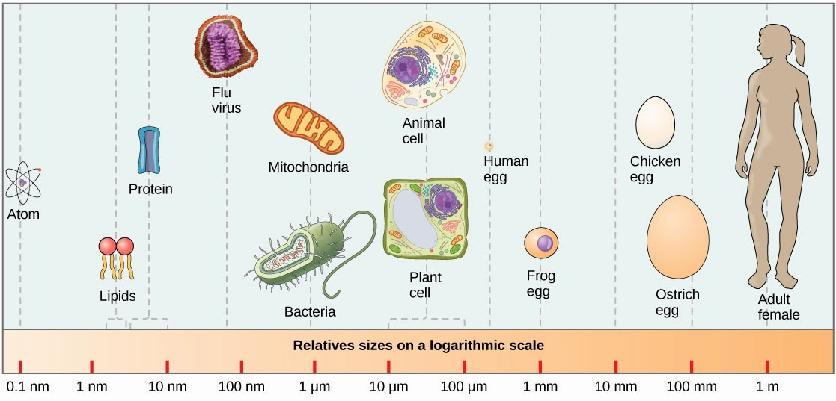
Variation in size also effect on
- Shape greatly varies
- Diversity
- Effects pathogenicity
Lecture # 13
A virus can be simply defined as an obligate intracellular parasite. Each viral particle, or virion, consists of a single nucleic acid, RNA or DNA, encoding the viral genome surrounded by a protein coat, and is capable of replication only within the living cells of bacteria, animals or plants. Viruses are classified into different orders and families by consideration of the type of nucleic acid present (RNA or DNA), whether the nucleic acid is single- or double-stranded, and the presence or absence of an envelope.
Structure: A typical virus consists of a protective protein coat, known as a capsid. The capsid shape varies from simple helical and icosahedra forms to more complex structures with tails. The capsid provides protection for the viral genome against the environment and functions in receptor recognition, targeting the virus to a susceptible host and cell type.
Some viruses have a phospholipid envelope, derived from the infected host’s cell membrane, that surrounds the protein capsid. Inserted into the lipid envelope there are usually viral encoded proteins know as spike projections – these are typically glycoproteins and are also involved in receptor recognition and viral tropism.
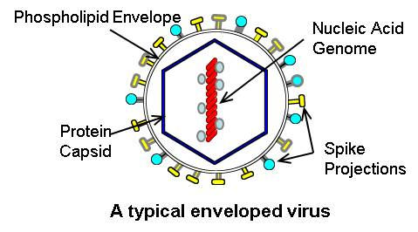
Major Criteria for Classifying Human Virus Families
Criterion | Basis of Classification
Type of genomic nucleic acid | DNA or RNA
Nucleic acid strandedness | ds, ss, partially ds
Sense of ss nucleic acid | +, −, − with ambisense
Capsid morphology | Icosahedral, helical, or complex
Envelope | Present or absent
Genome segmentation | Number of segments
Size of virion and/or genome | For example, large-genome DNA viruses (e.g., poxviruses, herpesviruses) versus small-genome viruses (e.g., picornaviruses, parvoviruses, hepadnaviruses)

ds, double stranded; ss, single stranded

Lecture # 14
As viruses are obligate intracellular pathogens they cannot replicate without the machinery and metabolism of a host cell. Although the replicative life cycle of viruses differs greatly between species and category of virus, there are six basic stages that are essential for viral replication.
1. Attachment: Viral proteins on the capsid or phospholipid envelope interact with specific receptors on the host cellular surface. This specificity determines the host range (tropism) of a virus.
2. Penetration: The process of attachment to a specific receptor can induce conformational changes in viral capsid proteins, or the lipid envelope, that results in the fusion of viral and cellular membranes. Some DNA viruses can also enter the host cell through receptor-mediated endocytosis.
3. Uncoating: The viral capsid is removed and degraded by viral enzymes or host enzymes releasing the viral genomic nucleic acid.
4. Replication: After the viral genome has been uncoated, transcription or translation of the viral genome is initiated. It is this stage of viral replication that differs greatly between DNA and RNA viruses and viruses with opposite nucleic acid polarity. This process culminates in the de novo synthesis of viral proteins and genome.
5. Assembly: After de novo synthesis of viral genome and proteins, which can be post-transrciptionally modified, viral proteins are packaged with newly replicated viral genome into new virions that are ready for release from the host cell. This process can also be referred to as maturation.
6. Virion release: There are two methods of viral release: lysis or budding. Lysis results in the death of an infected host cell, these types of viruses are referred to as cytolytic. An example is variola major also known as smallpox. Enveloped viruses, such as influenza A virus, are typically released from the host cell by budding. It is this process that results in the acquisition of the viral phospholipid envelope. These types of virus do not usually kill the infected cell and are termed cytopathic viruses.
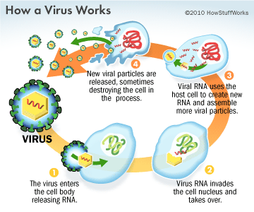
Lecture # 15
Lecture # 16
Lecture # 17
Lecture # 18
Lecture # 19
Lecture # 20
Lecture # 21

